10.1 – Analyzing Graphs of Quadratic Functions

For each quadratic function, find the indicated information:
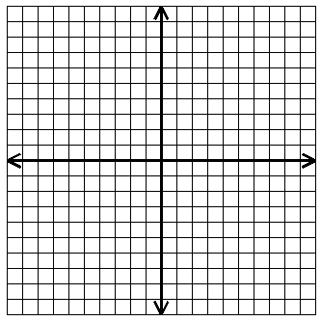
- $y=x²+4x+3$

Vertex: ___________
Axis of Symmetry: __________
Max or Min value: __________
Domain: _________
Range: _________
X-Intercepts: _________

- $y=3\left(x-2\right)²$

Vertex: ___________
Axis of Symmetry: __________
Max or Min value: __________
Domain: _________
Range: _________
X-Intercepts: _________

- $y=-2\left(x-2\right)\left(x+2\right)$

Vertex: ___________
Axis of Symmetry: __________
Max or Min value: __________
Domain: _________
Range: _________
X-Intercepts: _________

