4.1 – Relations, Domain and Range

Relation:

Relations can be expressed in 4 different ways:

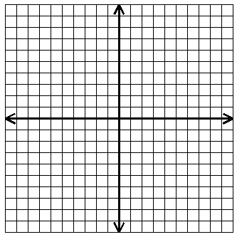

1. Represent the relation shown

in the graph as:
a) a set of ordered pairs

b) a table c) a mapping
$$x$$
$$y$$
$$x$$
$$y$$

Domain:

Range:

Function:

State the domain and range. Then determine whether or not the relation is a function.
2. $\{\left(2, 4\right), (3, 5), (6, 5), (-1, 3)\}$

$D=$_______________ Function?_______

$R=$_______________

3. $\left\{(1, 9), (-2, 5), (1, 6),(-4, -3), (2, 8)\right\}$

$D=$_______________ Function?_______

$R=$ ______________

4. Express the relation shown as ordered pairs. Then state
the domain and range. Is it a function?
$$2$$
$$1$$
$$0$$
$$-1$$
-4
$$12$$
$$5$$
$$0$$
$$-3$$

Domain:_________________

Range:__________________
Find the domain and range from the graph.
4.

Domain:____________

Range:_____________

5. 6.

Domain:__________ Domain:__________

Range:___________ Range:___________

6. 7.

Domain: __________ Domain:_________

Range:___________ Range:__________

Find the domain and range from the graph.
4.

Domain:____________

Range:_____________

5. 6.

Domain:__________ Domain:__________

Range:___________ Range:___________

6. 7.

Domain: __________ Domain:_________

Range:___________ Range:__________

