6.2 – Graphing Special Cases

Plot the points $\left(7, 3\right), \left(-4, 3\right), \left(1, 3\right), \left(-6, 3\right)$.
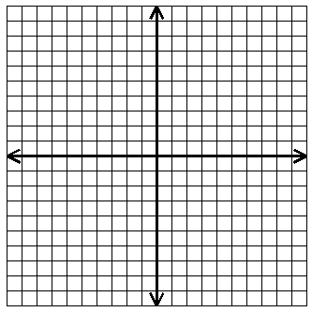
Draw the line.
What do you notice about the points?

Equation:_______

$m=$ _____ $b=$_____

Plot the points $\left(-5, 2\right), \left(-5, -4\right), \left(-5, 6\right), \left(-5, -8\right)$.
Draw the line.
What do you notice about the points?

Equation:_____________

$m=$ ______ $b=$ ______

Graph $y=-7$ Graph $x=2$

