8.1 – GRAPHING SYSTEMS OF EQUATIONS

Solve each system by graphing.
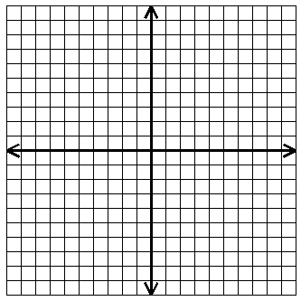
1. $2x – y = 8$
$$x + y = 1$$

CHECK:

2. $2x + y = 2$
$$x – y = 4$$

3. $x – 3y = 6$
$$x – 3y = -3$$

4. $2x – y = 1$
$$6x – 3y = 3$$

