8.3 – Graphing Systems of Inequalities

Solve each system. Name 3 points in the solution.
Name 3 points not in the solution.
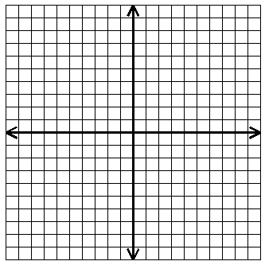
- $x>5$
$$y≤4$$

- $y≤2x+3$
$$y<-x+1$$

- $2y+x<6$
$$3x-y<4$$

- $2x+y>4$
$$3x-y≤6$$

