NAME__________________________DATE___________________PERIOD____

8.3 – Graphing Systems of Inequalities

State which of the following points are solutions to the system of inequalities graphed below.
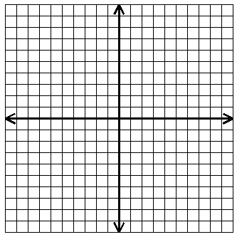

1. $(0, 0)$ __________

2. $(-1, 4)$ __________

3. $(2, 5)$ __________

4. $(1, -1)$ __________

5. $(3, 2)$ __________

Solve each system of inequalities.

6. $x>5$ 7. $y<0$
$y≤4$ $x≥0$

8. $y<-3$ 9. $y<2x+3$
$x-y>1$ $y<-x+1$

10. $x+4y<8$ 11. $3x-5y≥-10$
$3x-y≥4$ $4x-2y≤10$

A
B

12. Find the domain and range.

D:____________ R:____________

13. Find the equation of the line containing the point $(4, -2)$ with $slope=-3$.

14. Solve: $–5(k+4)≥3(k-4 )$

