REVIEW FOR FALL SEMESTER
NAME____________________________

- Write each interval shown in the following graphs in set builder and interval notation.
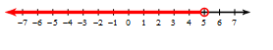  Set builder: __________________________________  Interval: ____________________________________ | Set builder: __________________________________  Interval: ____________________________________
- State the domain and range of each function in interval and set builder notation.
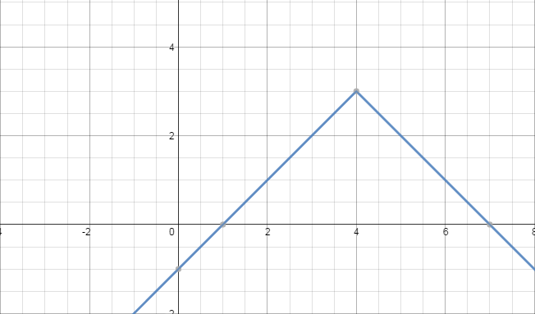  Domain: ____________________________________  Range: ______________________________________ | 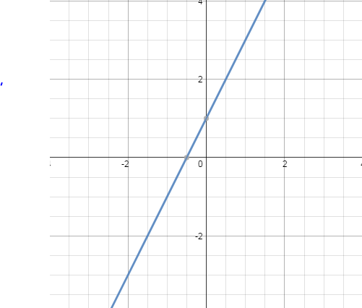  Domain: ____________________________________  Range: ______________________________________
- Graph the following functions and their parent functions and describe the transformations.
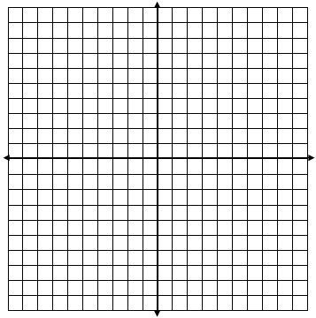  - $h\left(x\right)=-\frac{2}{3}x+6$ | - $f\left(x\right)={(x+2)}^{2}-3$
- Write the function given the transformations.
- The function $g\left(x\right)=\left|x\right|$ is horizontally translated right three units and vertically stretched by a factor of $6$.

- The function $h\left(x\right)=x$ is vertically shrunk by a factor of $\frac{5}{6}$, reflected across the axis and vertically translated down $2$ units.

- Write the function $g\left(x\right)$ whose graph represents the indicated transformations.
- The function $f\left(x\right)={3x}^{2}-1$ is reflected across the x-axis, horizontally translated right $1$unit, and vertically translated down $2$ units.

- The function $f\left(x\right)={(x-9)}^{2}$ is vertically shrunk by a factor of $\frac{1}{4}$, horizontally translated left $3$ units, and vertically translated up $4$ units.

- The function $f\left(x\right)=2x+3$ is vertically stretched by $3$ and shifted down $5$ units.

- Solve the following equations for $x$.
- $-\frac{13}{12}-\frac{5}{3}x=x-\frac{15}{4}$ | - $5x-5=3x+3$
- Solve the following absolute value equations.
- $\left|5x+10\right|=15$ | - $\left|6x+5\right|=11$
- Solve the following absolute value inequalities.
- $\left|2x+4\right|≤8$ | - $\left|2x-3\right|≥5$
- Write the equation of each line described below.
- Slope $=-3$, y –intercept $=4$ in slope-intercept form

- Slope $=\frac{1}{2}$, passes through $\left(4, -1\right)$ in point-slope form

- Through the points $\left(-2, -1\right)$ and $\left(7, -3\right)$ in slope-intercept form

Systems of Equations
- Where do the lines $y=2x$ and $5x-y=30$ intersect?

- SOLVE: $x+y=9$  $x-3y=-3$ | - SOLVE: $3x+y=4$  $x-2y=6$
- SOLVE: $2x+y+2z=11$
$x+z=6$
$-3y+z=7$

- Solve the following systems of inequalities.
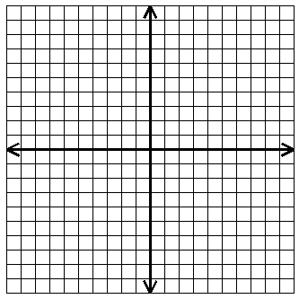
- $2y+x<6$
$3x-y>4$

- $x>-2$
$y≤2x+7$

- Graph the following quadratic equations and identify the given characteristics.
- $y=2\left(x+1\right)\left(x+3\right)$
Vertex:

Axis of Symmetry:

Max or Min Value:

Domain:

Range:

Roots:________________________

- $y={\left(x-2\right)}^{2}-9$
Vertex:

Axis of Symmetry:

Max or Min Value:

Domain:

Range:

Roots:________________________

- $y=-{2x}^{2}-4x+6$
Vertex:

Axis of Symmetry:

Max or Min Value:

Domain:

Range:

Roots:________________________

- Simplify the expressions and write in standard form.
- $\left(5-3i\right)-\left(18+8i\right)$ | - $\left(4+7i\right)\left(3-6i\right)$
- Simplify the following radicals.
- $-\sqrt{128}$ | - $\sqrt{-75}$
- Solve the following quadratic equations using square roots.
- ${\left(x-7\right)}^{2}=-12$ | - ${6x}^{2}-3=9$
- Solve the quadratic equation by factoring.
- $x^{2}+8x=-16$

- Solve the quadratic equation using the quadratic formula.
- ${-3x}^{2}+6x+12=0$

- Solve the quadratic equation by completing the square.
- $x^{2}+10x+14=0$

