4.2 – Functions #1
A function can also be a rule with input values (the DOMAIN) and output values (the RANGE).
Domain: $-1, 0, 1$ 3,
1.

The rule is
$2x+3$

Range:

Ordered pairs:_________________________________

FUNCTION NOTATION: $f\left(x\right)=2x+3$
To find $f\left(-1\right)$ you replace $x$ with $-1$

$f\left(-1\right)=$

2. Find the range values of each function for the given domain values.
a) $f\left(x\right)=x^{2}-3$ $D=\left\{-2, 0, 2, 4\right\}$

b) $g\left(x\right)=-2x-4$ $D=\left\{-4, -1, 2, 6\right\}$

3. For $h\left(x\right)=\left\{\left(-2, 6\right), \left(2, 8\right), \left(4, 10\right), \left(6, 12\right), \left(8, 14\right)\right\}$ find the indicated value.

$h\left(6\right)=$ _______ $h\left(-2\right)=$ ________ $h\left(8\right)=$ _________

If $f\left(x\right)=2-3x$ and $g\left(x\right)=2x^{2}-1$, find the following.

4. $f\left(-2\right)=$ 5. $g\left(5\right)=$

6. $f\left(4\right)+g\left(-1\right)=$

7. Find the domain and range.
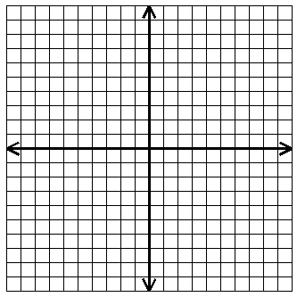
Domain:______________

Range:_______________

