4.3 – FUNCTIONS #2

- Find domain and range of the relation, then determine if the relation is a function. If it is not, tell why.
$$\left\{\left(-8, 4\right), \left(-2, 0\right), \left(1, -6\right), \left(1, 4\right), \left(7, -6\right)\right\}$$

Domain:___________________________

Range:____________________________

Function:

If $f\left(x\right)=x^{2}+4x$ and $g\left(x\right)=5-3x$, find the following.

2. $f\left(-3\right)=$ 3. $g\left(-5\right)=$

4. $f\left(1\right)+g\left(3\right)=$ 5. $f\left(-2\right)-g\left(4\right)=$

- $2\left[g\left(-2\right)\right]+3\left[f\left(2\right)\right]=$

Use the graph to answer
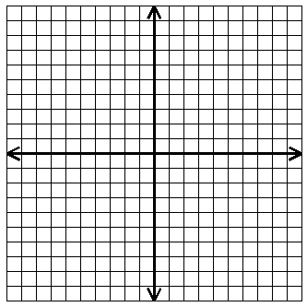
•
•
•
•
•
•
•
the following.

List the points.

Domain:

Range:

Function? What would make it a function?

$f\left(2\right)=$ ______ $f\left(-3\right)=$ _______

$f\left(x\right)=7$, $x=$ _______ $f\left(x\right)=-6$, $x=$ _______

Find the domain and
•
range.

D:_____________

R:_____________

