5.1 – Graphing Linear Functions

Given the following $x-values$, find the corresponding
$y-values$. Then graph the function.

1. $f\left(x\right)=2x+3$ $x=-5, -4, -1, 0, 1, 3$
$$y$$
$$x$$
$$x$$ | $f\left(x\right)=2x+3$ | $$y$$

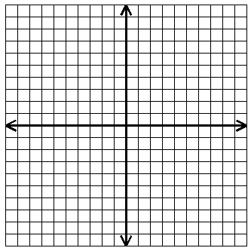

Domain:__________

Range:__________

2. $g\left(x\right)=\frac{1}{2}x+2$ $x=-8, -4, 0, 2, 6, 8$
$$y$$
$$x$$
$$x$$ | $$g\left(x\right)=\frac{1}{2}x+2$$ | $$y$$

Domain:_________

Range:_________

