Name_______________________________Date___________________Period_____

Unit 11 Review
Solve by FACTORING.
1. $\left(5x+3\right)\left(7x+1\right)=0$  Solution: _____________ | - $x^{2}+5x-24=0$  Solution: ________________
3. $7x^{2}-28x=0$  Solution: __________________ | - $x^{2}=35+2x$  Solution: _________________
- $2x^{2}=-3x+35$  Solution: __________________ | - $9x^{2}-64=0$  Solution: __________________
Solve each of the following using square roots. Leave answers in simple radical form, when necessary.
- $x^{2}-25=0$  Solution: _____________ | - ${64x}^{2}=49$  Solution: ________________
- $2x^{2}=176$  Solution: __________________ | - ${3x}^{2}-78=0$  Solution: _________________
Find the number of solutions for the following quadratic equations using the discriminant. Then, solve each equation using the quadratic formula.

11. $x^{2}-10x+16=0$ $a=______b=_____c=_____$

Number of Solutions: _____

Solutions:______________

12. $3x^{2}+8x+4=0$ $a=______b=_____c=_____$

Number of Solutions: _____

Solutions:______________

13. $6x^{2}-13x+6=0$ $a=______b=_____c=_____$

Number of Solutions: _____

Solutions:______________

Review
14. SOLVE: $7\left(x+4\right)-2\left(x+3\right)=6\left(x+5\right)$

15. SIMPLIFY: $\left(x^{2}-4x-1\right)-\left(-x^{2}+7x+2\right)$

16. Factor: $36x^{3}-27x^{2}+18x$

Use the graph below to answer 17 – 18.
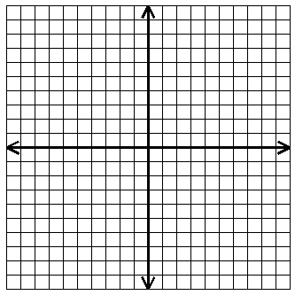
17. What is the slope of the line?__________

18. What is the equation of the line shown?_______________

19. Which inequality best describes the graph? 20. What are the x- and y-intercepts
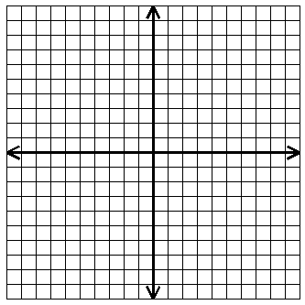
for the graph shown?

A. $x-y≥-3$
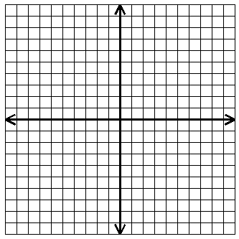
B. $x+y≥3$
C. $x+y≤3$
D. $x-y≤3$
E. $x+y≤-3$

ANSWERS

$$x=\frac{-3}{5}, \frac{-1}{7}$$
$$\left(-5, 0\right) \& \left(0, 2\right)$$
$$y≥x-3$$
$$y=2x$$
$$2$$
$$9x\left(4x^{2}-3x+2\right)$$
$$2x^{2}-11x-3$$
$$2$$
$$2$$
$$2$$
$$x=-8$$
$$x=\frac{3}{2}, \frac{2}{3}$$
$$x=\frac{-2}{3}, -2$$
$$x=8, 2$$
$$x=±\sqrt{26}$$
$$x=±2\sqrt{22}$$
$$x=±\frac{7}{8}$$
$$x=±5$$
$$x=\frac{8}{3}, \frac{-8}{3}$$
$$x=\frac{7}{2}, -5$$
$$x=-5, 7$$
$$x=0, 4$$
$$x=-8, 3$$

