NAME____________________________________DATE______________PERIOD___

UNIT 4 TEST REVIEW

1.
- List the ordered pairs:

B. Domain: ___________________________

C. Range: ____________________________

D. Is it a function? YES NO

E. Why or why not? _____________________
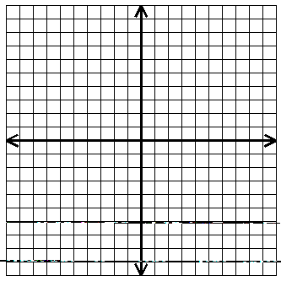

Find the domain and range.
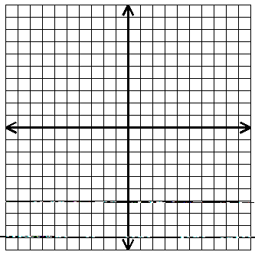
2. 3.

D:______________ R:_____________ D:______________ R:______________

Find the range of each function for the given domain.

4. $f\left(x\right)=4x+3$ $D=\left\{3, 0, -3\right\}$ $R=$______________________

5. $g\left(x\right)=x^{2}-2$ $D=\left\{2, -1, -4\right\}$ $R=$_______________________

If $f\left(x\right)=2-3x$ and $g\left(x\right)=x^{2}+6$, find the following.

6. $f\left(-3\right)=$ _______ 7. $g\left(-2\right)=$ _______ 8. $g\left(3\right)-f\left(2\right)=$________

MIXED REVIEW

9. Evaluate: $\left|-10+\left|-5\right|\right|=$

10. Solve: $4x-\left(x-3\right)=15$

11. Evaluate: $ab-c^{2}$when $a=4$, $b=-1$, and $c=-2$

12. Solve: $P=2a+b+c$ for $a$.

13. Simplify: $3\left(9x+4y\right)+6x-\left(3x+8y\right)-2y\left(7+y\right)$

Answers

$$\left\{\left(7, 2\right), \left(3, -4\right), \left(0, 6\right), \left(-2, 1\right), \left(-5, 0\right), \left(-5, -4\right)\right\}$$

$$\left\{7,3,0,-2,-5\right\}$$
$$x≥-3$$
$$y≤5$$

$$30x-10y-2y^{2}$$

$$\left\{2, -4, 6, 1, 0\right\}$$
$$11$$

$$3<y≤ 7$$
$$10$$

NO
$a=\frac{P-b-c}{2}$

$$\left\{15, 3, -9\right\}$$
$$5$$
$$\left\{2, -1, 14\right\}$$
$$19$$

$$4$$

$$-8$$

$$-2<x<4$$

