Name______________________Date________________________Period____

Unit 5 Review

Find the slope of each line below.

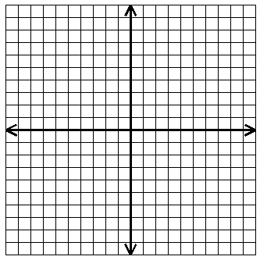

# 1

# 2

# 3

# 4

1. Line # 1:______________

2. Line # 2:______________

3. Line # 3:______________

4. Line # 4:______________

Find the slope of the line through the given points.

5. and 6. and $Q\left(-3, 5\right)$

$m=$ $m=$

$P\left(5, -8\right)$__________ __________

1. and

__________

Graph the following lines.

8. Through the point $\left(-4, -2\right)$ with 9. _____ _____

a slope of





10. _____ _____ 11. _____ _____





12. Through the point $A\left(-2, -1\right)$ 13. Where $m=-4$ and $b=2$

and a slope of

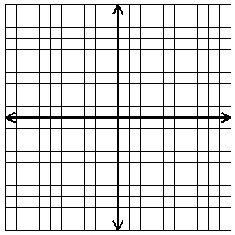



**Solve the following using direct variation.**

14. If varies directly as $x$ and $y=12$ when $x=3$, find when .

_______________

15. The distance, $d$, varies directly with the time, $t$. If you have driven $225 miles$ for $5 hours$, how long would it take you to drive $315 miles$?

_______________

**Review**

16. If , find the **range** if the domain is . ________

17. If , find and **.** ______

______

18. Solve:

19. Solve:

20. Simplify:

21. Evaluate:

22. Simplify. THEN evaluate for , and .

23. Solve: for

**ANSWERS**







$$\frac{7}{8}$$

$$0$$

$$\frac{3}{2}$$

$$-\frac{4}{7}$$

$$-\frac{2}{7}$$

$$\left\{9, 1, 19\right\}$$

$$-\frac{1}{3}$$

$$\frac{2}{7}; -4$$

$$\frac{P}{2}-W=L$$

$$64$$

$$37$$

$$22$$

$$-2$$

$$7$$

$$-5$$

$$7$$

$$5$$

$$6$$

$$-\frac{2}{5}; -2$$

$$\frac{1}{2};2$$

Undefined