Name______________________Date________________________Period____

Unit 6 Review

Graph the following lines.

1. $2x-4y=-8$ $m=$_____ $b=$_____ 2. $2x+5y=10$ $m=$_____ $b=$_____

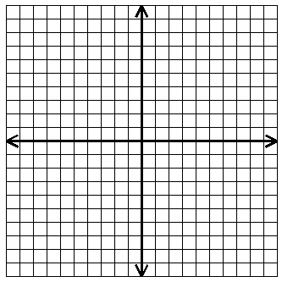

3. $5x-2y=10$ $m=$_____ $b=$_____ 4. $y=-1$ $m=$_____ $b=$_____

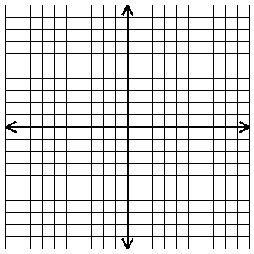

5. $x=-3$ $m=$_____ $b=$_____ 6. $2y=4x$ $m=$_____ $b=$_____

Use the graph below to answer the following questions.
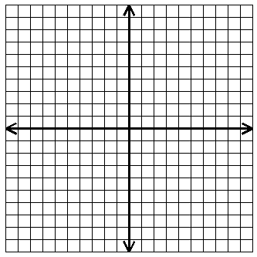
7. What is the slope of the line? __________

8. What is the y-intercept of the line?__________

9. What is the equation of the line?__________

10. What is the value of “$y$” when $x=6$?__________

11. What is the value of “$x$” when $y=-4$?__________

12. Write the equation for the given line.

$m=$ ________ $b=$ __________

Equation:____________________

Use the graph below to answer the following questions.
$$B$$
For line $A$ find:
$$A$$

13. Slope = ________

14. y-intercept = ________

15. The value of $x$ when $y=5$________

- The value of $y$ when $x=6$ ________

- The equation of line $A$_______________

For line $B$ find:

18. Slope = ________

19. y-intercept = ________

- The value of $x$when $y=6$ ________

- The value of $y$ when $x=2$ ________

- The equation of line $B$_______________

Write the equation of the line given the following information.
- Slope of $2$ and y-intercept of $3$ | _______________________________
- Slope of $-\frac{3}{5}$ and passing through $\left(-5, -1\right)$ | _______________________________
- Slope of $0$ and passing through $\left(-2, 8\right)$ | _______________________________
- Slope of $-\frac{4}{3}$ and x-intercept of $3$ | _______________________________

- Vertical line through $\left(-1, 2\right)$ | _______________________________
- Horizontal line through $\left(2, 4\right)$ | _______________________________
Solve the following.
- Circle the points that lie on the following line.  $$2x+3y=9$$ | a. $\left(6, -1\right)$  b. $\left(0, 0\right)$  c. $\left(-3, 5\right)$
30. What is the range of $f\left(x\right)=x^{2}-2x+1$  when the domain is $\left\{-10, 3, -5\right\}$? | $R=$_________________
31. Solve for $x$: $3\left(x+3\right)-2\left(x-1\right)=4\left(3x\right)$ | $x=$_______
- If $\left(2, y\right)$ is a solution to the equation  $2x-y=3$, what is the value of $y$? | $y=$ _______

Answers
$$y=-\frac{2}{3}x+3$$
$$y=-\frac{2}{3}x+2$$
$$-\frac{3}{5}$$
$$1$$
$$y=8$$
$$x=-1$$
$$1$$
$$2$$
$$4$$
$$2$$
$$9$$
$$-\frac{2}{3}$$
$$-2$$
$$y=4$$
$$y=4x-2$$
$$\frac{5}{2}$$
$$2$$
$$\left(-3, 5\right)$$
$$0$$
$$y=2x$$
$$-2$$
$$\frac{1}{2}$$
$$y=-\frac{3}{5}x-2$$
$$-3$$
$$-\frac{2}{3}$$
$$0$$
$$None$$
$$2$$
$$-\frac{2}{5}$$
$$y+1=-\frac{3}{5}\left(x+5\right)$$
$$y=\frac{1}{2}x+2$$
$$-1$$
$$-5$$
$$Undefined$$
$$y=\frac{5}{2}x-5$$
$$y=2x+3$$
$$y=-\frac{2}{5}x+2$$
$$\left\{121, 4, 36\right\}$$
$$y=-\frac{4}{3}\left(x-3\right)$$
$$\left(6, -1\right)$$
$$6$$
$$2$$
$$-1$$
$$3$$
$$-2$$

