# Name _________________________________ Date __________________ Period _________

## Unit 7 Review

**Graph the following equations.**

1. $x+2y=8$ 2. $3x+5y=-10$

slope-intercept form:____________________ slope-intercept form:

$m=$ $b=$ $m=$ $b=$



$y=4x+2$



$m=$ $b=$

___________________

______ _______ ______ _______

______ _______

**Graph the following linear inequalities.**

1. 5.

6. 7.

**Graph the following absolute value equations.**



|  |  |  |
| --- | --- | --- |
|  |  |  |
|  |  |  |
|  |  |  |
|  |  |  |
|  |  |  |
|  |  |  |
|  |  |  |
|  |  |  |

|  |  |  |
| --- | --- | --- |
|  |  |  |
|  |  |  |
|  |  |  |
|  |  |  |
|  |  |  |
|  |  |  |
|  |  |  |
|  |  |  |



|  |  |  |
| --- | --- | --- |
|  |  |  |
|  |  |  |
|  |  |  |
|  |  |  |
|  |  |  |
|  |  |  |
|  |  |  |
|  |  |  |

11.

|  |  |  |
| --- | --- | --- |
|  |  |  |
|  |  |  |
|  |  |  |
|  |  |  |
|  |  |  |
|  |  |  |
|  |  |  |
|  |  |  |

**Write the equation of the line with the following conditions.**

1. $slope=\frac{1}{3}$, $y-intercept=2$

$slope=\frac{2}{3}$__________________________________________

1. , passes through $\left(2, 6\right)$

__________________________________________

1. undefined slope, passes through $\left(6, 1\right)$

__________________________________________

**Multiple Choice**

15. Which equation describes the graph below?

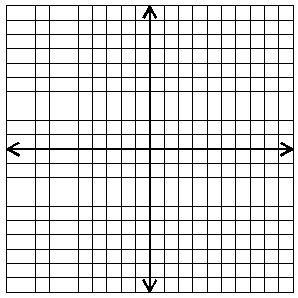

16. Which equation represents the line that passes through the point $\left(-3, 2\right)$ and has a slope of ?



17. Which inequality best describes the graph below?

18. Which graph best represents the inequality $-x+y≥6$?



1. B.







C. D.

**Review**

19. Find and graph the solution to the inequality .

20. Find and graph the solution to the inequality .

21. Find and graph the solution to the inequality $-7≤9x+2≤11$.

**Answers**

C

C

D

$$2$$

$$-1$$

$$-1$$

$$1$$

$$1$$

$$-\frac{4}{3}$$

$$y-6=\frac{2}{3}\left(x-2\right)$$

$$-2$$

$$y=-\frac{3}{5}x-2$$

$$-1≤x≤1$$

$$4$$

$$2$$

$$-\frac{3}{5}$$

C

$$y=-\frac{1}{2}x+4$$

$$x=6$$

$$y=\frac{1}{3}x+2$$

$$4$$

$$-\frac{1}{2}$$

$$x>2 or x<-1$$

$$y<-\frac{4}{3} or y≥1$$