Name____________________________ Date__________________ Period________

Unit 8 Test Review

Solve the following systems of equations using graphing, elimination, or substitution. The graph is provided for use when solving by graphing.

- $y=4x-5$
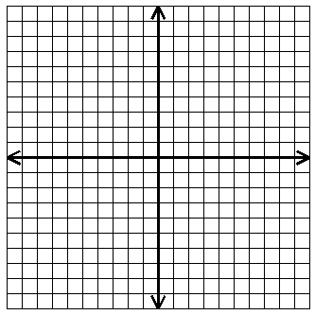
$8x-2y=16$ SOLUTION:_____________

- $2x-y=1$
$3y+3=6x$ SOLUTION:_____________

3. $4x-2y=10$
$3x-y=12$ SOLUTION:_____________

4. $5x-9y=-3$
$4x-3y=6$ SOLUTION:_____________

5. Solve by all 3 methods. A. GRAPHING
$5x+2y=4$
$x-y=5$

B. SUBSTITUTION

C. ELIMINATION SOLUTION:__________

Based on the graph of the following systems, determine the solutions.

6. SOLUTION:___________ 7. SOLUTION:__________ 8. SOLUTION:__________
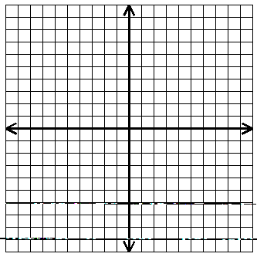

9. Determine if $\left(5, 1\right)$ is a solution to the system. $4x-7y=13$
$2x-7y=3$

Graph and shade the solution heavily.
10. $x≥3$ 11. $y<2x-2$
$y< -4$ $4y-3x≤8$

12. $2y+x< 6$
$3x-y>4$

Write the equation of the line given the following information.

13. slope $\frac{1}{3}$, y-intercept $-5$ __________________________

14. line passes through $\left(1, 5\right)$ with slope $2$ __________________________

15. slope $0$ and passes through $\left(-1, 2\right)$ ________________________

16. Graph problem #15. 17. Write the equation of the line in the graph below.
•
•

________________________

18. If $\left(x, -2\right)$ is a solution to the equation $3x-y=14$, what is the value of $x$?

ANSWERS
$$\left(3, 2\right)$$
$$Infinite Solutions$$
$$\left(7, 9\right)$$
$$No Solution$$

$$\left(2, -3\right)$$
$$No Solution$$
$$Yes$$
$$Infinite Solutions$$
$$\left(2, 2\right)$$

$$y=\frac{1}{3}x-5$$
$$x=4$$
$y=\frac{2}{3}x-2$
$$y=2$$

$$y-5=2\left(x-1\right)$$

