Name __________________________________ Date ___________________ Period __________

10.1 – Analyzing Graphs of Quadratic Functions

1. $y=2{\left(x-2\right)}^{2}-2$  Vertex:  Axis of Symmetry:  Max or Min Value:  Domain:  Range:  X-intercepts: | 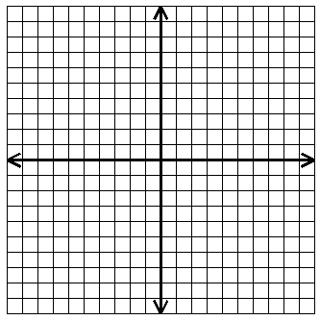
2. $y=-2\left(x+3\right)\left(x-1\right)$

Vertex:
Axis of Symmetry:

Max or Min Value:
Domain:
Range:
X-intercepts:

3. $y=-2x^{2}+4x$

Vertex:
Axis of Symmetry:

Max or Min Value:
Domain:
Range:
X-intercepts:

4. $y=\left(x-5\right)\left(x-3\right)$

Vertex:
Axis of Symmetry:

Max or Min Value:
Domain:
Range:
X-intercepts:

5. $y=-x^{2}+9$

Vertex:
Axis of Symmetry:

Max or Min Value:
Domain:
Range:
X-intercepts:

6. $y={\left(x+3\right)}^{2}-9$

Vertex:
Axis of Symmetry:

Max or Min Value:
Domain:
Range:
X-intercepts:

