Name_______________________________Date__________________________Period_______

4.1 – Relations, Domain and Range
1. Represent the relation shown in the graph as a set of ordered pairs, a table and a mapping.
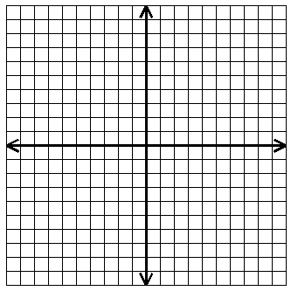
a) set of ordered pairs

_______________________________________

b) a table c) a mapping
$$x$$
$$y$$
$$x$$
$$y$$

2. Draw a mapping and a graph for each relation.
a) $\left\{\left(8, 2\right), \left(4, 2\right), \left(8, -9\right), \left(7, 5\right), \left(-3, 2\right)\right\}$
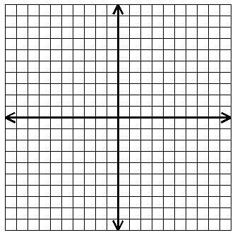
$$y$$

$$x$$

$$x$$
$$y$$
$$3$$
$$2$$
$$-3$$
$$1$$
$$3$$

$$3$$
$$7$$
$$3$$
$$3$$
$$1$$
b)
$$x$$
$$y$$

State the domain and range. Then determine whether or not the relation is a function.

3) $\left\{\left(0, 2\right), \left(-3, 1\right), \left(4, -5\right), \left(7, 4\right)\right\}$ Function: YES or NO

Domain:_________________________ Range:___________________________

4) $\left\{\left(4, 9\right), \left(-4, 0\right), \left(4, -5\right), \left(-4, -9\right)\right\}$ Function: YES or NO

Domain:________________________ Range:___________________________

5) $\left\{\left(5, 3\right), \left(-2, 7\right), \left(7, -2\right), \left(5, -3\right)\right\}$ Function: YES or NO

Domain:_______________________ Range:__________________________

Express the relations shown in each table, mapping, or graph as a set of ordered pairs. Then state the domain and range. Tell whether the relation is a function.
6.
$$-2$$
$$3$$
$$4$$
$$6$$
$$3$$
$$8$$
$$12$$
$$x$$
$$y$$
Ordered pairs:__________________________

Domain:_______________________________

Range:_______________________________

Function: YES or NO

7.
Ordered Pairs:________________________________________

Domain:_____________________________________________

Range:______________________________________________

Function: YES or NO

8. Cost of admission to Water World
Number of people | $$1$$ | $$2$$ | $$3$$ | $$4$$
Cost (dollars) | $$28$$ | $$50$$ | $$80$$ | $$100$$

Ordered Pairs:________________________________________

Domain:_____________________________________________

Range:______________________________________________

Function: YES or NO

Find the domain and range from the graph.

9. 10.

Domain:__________________ Domain:__________________

Range:___________________ Range:___________________

11. 12.

Domain:__________________ Domain:__________________

Range:___________________ Range:___________________

13. 14.

Domain:__________________ Domain:__________________

Range:___________________ Range:__________________

