Name_____________________________Date_____________________Period_____

4.2 – FUNCTIONS #1

Find the range of each function for the given domain.

1. $f\left(x\right)=6x-1 D=\left\{0, 2, 4\right\} R=$ ____________

2. $g\left(x\right)=-2x-1 D=\left\{-3, -2, 5\right\} R=$ ____________

3. $k\left(x\right)=-x-5 D=\left\{-2, -1, 4\right\} R=$ ____________

4. $g\left(x\right)=2x^{2}-6 D=\left\{-3, -4, 5\right\} R=$ ____________

5. $f\left(x\right)=\left|x\right| D=\left\{-3, 0, 3\right\} R =$ ______________

6. $f\left(x\right)={\left(x-2\right)}^{2} D=\left\{-4, 0, 4\right\} R =$ _____________

If $f\left(x\right)=3x-1$ and $g\left(x\right)=x^{2} +1$, find the following.

7. $f\left(3\right)=$ ___________ 8. $g\left(3\right)=$ ___________

9. $f\left(2\right)=$ ___________ 10. $g\left(2\right)=$ ___________

11. $f\left(-1\right)+g\left(4\right)=$____________ 12. $g\left(-4\right)+f\left(-2\right)=$__________

For $g=\left\{\left(-5, 2\right), \left( -4, -1\right), \left(3, -8 \right), \left( -2, 0\right), \left(4, -9 \right)\right\}$ find the indicated value

13. $g\left(-4\right)=$ _______ 14. $g\left(4\right)=$ ______

15. $g\left(3\right)=$ _______ 16. $g\left(-5\right)=$ _______

17. Find the following for the 18. Find the domain and range.
graph below.
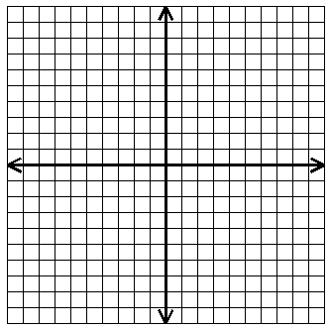

Ordered pairs:_____________________

Function: YES or NO

Domain:__________________________

Range:___________________________
Domain:______________

Range:_______________

