NAME________________________DATE____________________PERIOD____

4.3 – FUNCTIONS #2

Determine whether each relation is a function. If it is not a function, tell why.

|  |  |
| --- | --- |
|  |  |
|  |  |
|  |  |
|  |  |
|  |  |
|  |  |

|  |  |
| --- | --- |
|  |  |
|  |  |
|  |  |
|  |  |
|  |  |
|  |  |

1. ________ 2. ________

3. ________ 4. ________

1. ________

6. ________

If and , find each value.

7. 8. 9.

10. 11. 12.

13. 14. 15.

16. If , find the range if the domain is $\left\{-3, -2, 4, 6\right\}$.

Use the graph to answer the following.

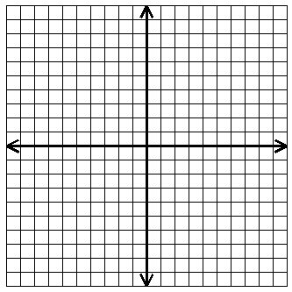

•

•

•

•

•

•

•

•

17. List the ordered pairs in the relation.

____________________________________________

18. What is the domain of the relation?

____________________________________________

19. What is the range of the relation?

____________________________________________

20. Is the relation a function?__________ Why?_______________________________

21. _______ 22. _______ 23. _______

24. , ______ 25. , _______ 26. , _______

Find the domain and range of the following.

27. 28. 29.

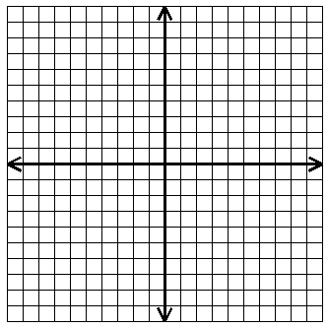

**°**

**°**



•

**°**

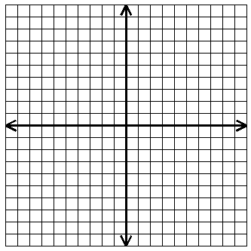

•

•

D:_________________ D:_________________ D:_________________

R:_________________ R:_________________ R:_________________