NAME________________________DATE____________________PERIOD______

5.1 – GRAPHING A FUNCTION

Given the following $x-values$, find the corresponding $y-values$. Then, graph the function.
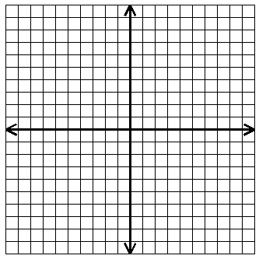
1. $f\left(x\right)=-2x$ $x=-4, -3, -1, 0, 2, 5$
$$x$$
$$y$$
$$x$$ | $$f\left(x\right)=-2x$$ | $$y$$

2. $f\left(x\right)=4x-2$ $x=-2, -1,0, 1, 2, 3$
$$x$$
$$y$$
$$x$$ | $$f\left(x\right)=4x-2$$ | $$y$$

3. $f\left(x\right)=-3 x+1$ $x=-3, -1, 0, 1, 2, 3$
$$x$$
$$y$$
$$x$$ | $f\left(x\right)=-3 x+1$ | $$y$$

4. $f\left(x\right)=-\frac{1}{2}x-3$ $x=-10, -6, -2, 0, 4, 10$
$$x$$
$$y$$
$$x$$ | $$f\left(x\right)=-\frac{1}{2}x-3$$ | $$y$$

Simplify.

5. $-5\left(3y-7\right)-\left(6+4y\right)$ 6. $3\left(4x-2\right)-2\left(2x+3\right)-5$

Solve.

7. $-9-3\left(2r-1\right)=-18$ 8. $\frac{6x-2}{7}=\frac{5x+7}{8}$

