# NAME_________________________________DATE_______________PERIOD___

**5.2 – Slope**

Find the slope of the line that goes through the following points.

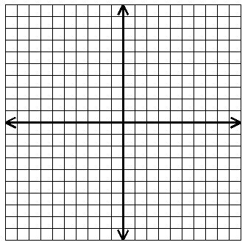

**A**

**B**

**C**

**D**

**E**

**F**

**G**

**H**

**I**

**J**

**K**

**L**

**M**

**N**

**P**

|  |
| --- |
| 1. Points A to D:_________ |
| 2. Points F to C :_________ |
| 3. Points I to M :_________ |
| 4. Points B to D:_________ |
| 5. Points H to L :_________ |
| 6. Points P to M:_________ |
| 7. Points J to L :_________ |
| 8. Points B to C:_________ |
| 9. Points A to J : _________ |
| 10. Points E to K:_________ |
| 11. Points C to M:________ |
| 12. Points N to B:________ |
| 13. Points L to P:________ |
| 14. Points G to D:________ |
| 15. Points C to P:________ |
| 16. Points D to K:________ |
| 17. Points P to H:________ |
| 18. Points K to P:________ |

**Determine the slope of each line.**

19. _________ 20. _________





21. _________ 22. _________





**Determine the slope of the line that passes through each pair of points.**

23. and 24. and

25. and 26. and

**Use for #’s 27 – 29.**

27. Domain:_________________________ Range:________________________

28. Is a function?______________

29. __________

30. Solve for :