NAME_______________________DATE___________________PERIOD_____

6.2 – Graphing Special Cases

Find the slope.

1. $m=$ __________ 2. $m=$ __________
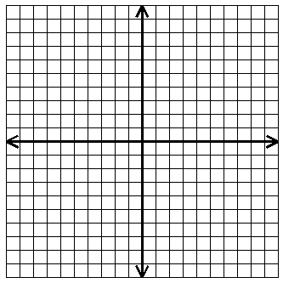

3. $\left(1, 2\right)$ and $\left(-3, 10\right)$ $m=$ ______ 4. $\left(4, 7\right)$ and $\left(-6, 7\right)$ $m=$ _____

Graph each line.

5. $y=\frac{1}{3}x-7$ $m=$ _____ $b=$ _____ 6. $y=x+4$ $m=$ _____ $b=$ _____

7. $3x+y=5$ 8. $2x-5y=-10$

$m=$ _____ $b=$_____ $m=$ _____ $b=$ _____

9. $x=-2$ $m=$ _____ $b=$ _____ 10. $y=6$ $m=$ _____ $b=$_____

