Name _________________________________ Date _________________ Period __________

7.2 – Graphing Linear Inequalities

Graph the following linear inequalities.
- $x≤4$ | 2. $6y<12$
- $y<\frac{3}{4}x-5$ | - $-x+y≤2$
- $y≥2x+10$ | 6. $4x+3y>12$
- $-6x+y≥3$ | 8. $-x+y>-2$
- $7x-7y>-21$ | 10. $2x+4y<-8$

- Which graph best represents the inequality $-x+y≥6$?
A. B.
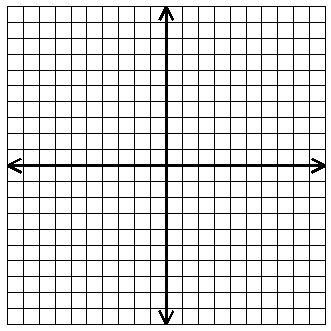

C. D.

