NAME______________________________DATE_______________________PERIOD_________

8.2 – Solving Systems Algebraically

Solve each system using elimination.

1. $x+y=8$ 2. $x-3y=7$
$x-y=4$ $x+2y=2$

Solution:__________ Solution:__________

3. $5x+2y=6$ 4. $2x+3y=13$
$9x+2y=22$ $x-3y=2$

Solution:__________ Solution:__________

5. $2x-5y=-6$ 6. $3x-5y=-35$
$2x-7y=-14$ $2x-5y=-30$

Solution:__________ Solution:__________
7. $x+5y=4$ 8. $-5x+3y=6$
$3x-7y=-10$ $x-y=4$

Solution:__________ Solution:__________

9. $8x-3y=-11$ 10. $4x-7y=10$
$2x-5y=27$ $3x+2y=-7$

Solution:__________ Solution:__________

Use substitution to solve each system of equations.

11. $y=3x-8$ Solution:__________
$x+y=4$

12. $2x+7y=3$ Solution:__________
$x=1-4y$

13. $4x+5y=11$ Solution:__________
$y=3x-13$

14. $3x-5y=11$ Solution:__________
$x=3y+1$

15. $x-5y=2$ Solution:__________
$2x+y=4$

16. $2x+3y=1$ Solution:_______
$-3x+y=15$

17. $5x-y=5$ Solution:__________
$-4x+5y=17$

18. $x+3y=12$ Solution:__________
$x-y=8$

19. State whether the given ordered pair is a solution to the system. (SHOW WORK)

$(1, -2)$ $x+2y=-3$ __________
$x-y=1$

20. Solve the system in three ways. $x-2y=2$
$3x+y=6$

GRAPHING Solution:__________ ELIMINATION Solution:_______
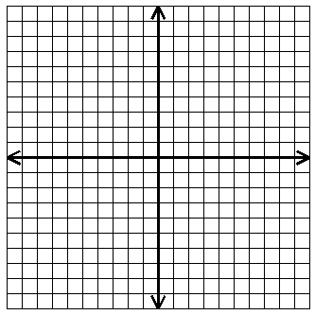

SUBSTITUTION Solution:_______

